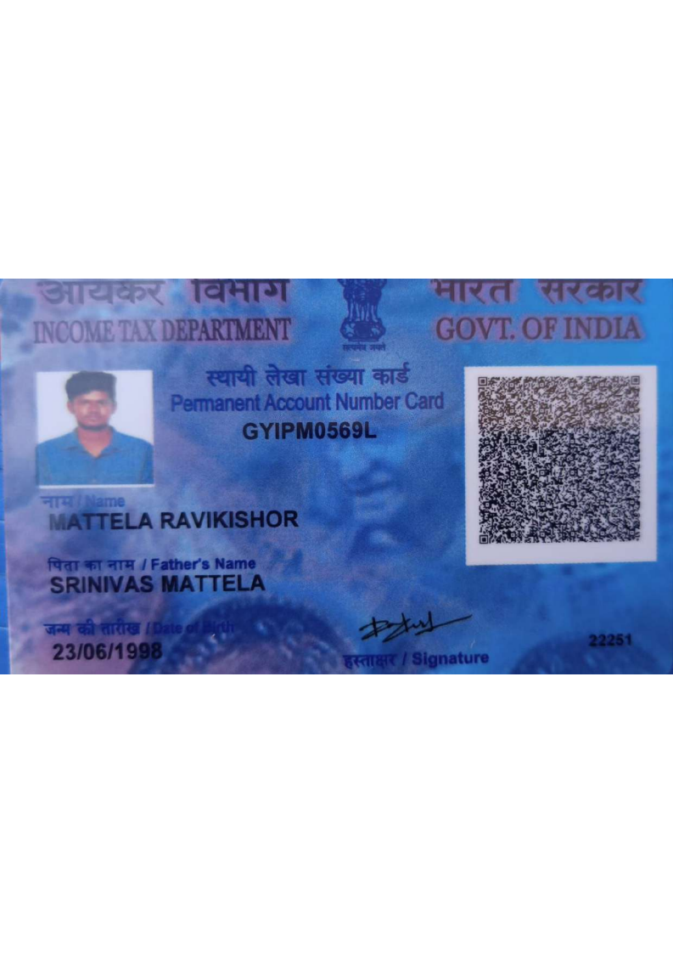

Candidate's Full Legal Name (as it appears on PAN)Vishal Nikam | RAVI KISHOR MATTELA
Supplier Name (Registered Name) | People-prime Worlwide
Worked for CG previously? (IF yes share CG  Employee ID/GGID required | No
JOB Posting ID | CGEMJP00347200
Contact No (10 Digit No) | 919346587579
Email IDirahulyaduvanshi1998@gmail.comravikishormattela310@gmail.com | ravikishormattela310@gmail.com
Job Location (Work Location) | Banglore
Notice Period (Immediate/ Notice to Serve) | Immediate Joiner
Highest Education (Regular or Distance) | B. SC (CS)
Employment Detail – Last 2 yrs Working period
(Payroll Company)
College & University Full Name -Biju Pat t naik University T echnology | Satavahana University, Karimnagar
Mandatory Skills & Experience  (quick checklist – verify each skill, years of  experience) | Java Full stack – 4.8 Years
“Secondary” Skills & Experience | React – 4.8 Years
Key Remarks (Supplier Comment) | Candidate Good at Communication Skill. He has relevant experience of 4.8 years.

Ravi Kishor Mattela
Hyderabad, Telangana | ravikishormattela310@gmail.com | 9346587579 |

Full Stack Developer

Java Full Stack Developer with 4.8 years of experience in designing, developing, and maintaining scalable enterprise web applications. Skilled in Spring Boot, Microservices, React.js/Angular, and Cloud technologies, with a strong focus on
delivering high-performance, end-to-end solutions in Agile environments and seeking to contribute technical expertise to a growth-oriented organisation while continuously enhancing professional skills.

EDUCATION

- BSc Computer Science: Comparison of Learning Algorithms, DBMS, Data Structure, And Algorithms

PROFESSIONAL SUMMARY

- Java Full Stack Developer with 4.8 years of IT experience in end-to-end development and maintenance of enterprise web applications using Java, J2EE, Spring Framework, and Spring Boot.
- Expertise in server-side programming with Spring MVC, Spring Boot and developing RESTful web services for scalable applications.
- Strong experience in front-end development using modern frameworks like React.js/Angular, along with core technologies HTML5, CSS3, JavaScript, and jQuery.
- Extensive hands-on experience with ORM frameworks, including Hibernate and JPA for database interactions.
- Proficient in building Microservices architecture and implementing event-driven communication using Kafka and RabbitMQ.
- Experience in implementing design patterns such as MVC, Singleton, Data Access Object (DAO), DTO, Service, Delegate, and Factory.
- Skilled in AWS Cloud Services, Docker containerization, and Kubernetes for application deployment and orchestration. • Hands-on experience with Continuous Integration/Continuous Deployment (CI/CD) pipelines using Jenkins and code quality tools like Sonar.
- Proficient in project building and dependency management tools, including Maven and Gradle.
- Containerised applications using Docker and deployed on Kubernetes (AWS).
- Built and maintained CI/CD pipelines using Jenkins and ensured code quality through SonarQube.
- Strong experience working in Agile/Scrum development methodologies with iterative deliveries.
- Implementing JUnit test cases using Spring Boot for test-driven development.
- Proficient in using version control systems like SVN and Git, and IDEs including IntelliJ IDEA, Eclipse

TECHNOLOGIES

Programming Languages: Java, JavaScript, TypeScript, SQL.
Frontend Technologies: React.js, HTML5, CSS3, JavaScript, TypeScript, jQuery.
Backend Technologies: Spring Boot, Spring MVC, Spring Security, Microservices, RESTful Web Services.

ORM & Database: Hibernate, JPA, PostgreSQL, Oracle, MySQL
Build & DevOps Tools: Maven, Gradle, Docker, Kubernetes, AWS, Jenkins, SonarQube, Git, SVN.
Servers & IDE: Apache Tomcat, WebLogic, IntelliJ IDEA, Eclipse, STS.
Methodologies: Agile/Scrum.

PROFESSIONAL EXPERIENCE

SOFTWARE ENGINEER
NCORE Technology PRIVATE LIMITED MAY 2023 – FEB 2026

Jr SOFTWARE ENGINEER
UNIFIED POINTS TECH PVT LTD July 2021 – April 2023

PROJECTS

Freight Management System Client: BNSF Railway
Role: Java Full Stack Developer
Technologies: Java, Spring Boot, React.js, TypeScript, Kafka, Docker, Kubernetes, AWS, PostgreSQL, JUnit, Jenkins.
Enhanced a freight management system for real-time rail cargo tracking and booking. Worked on both backend
microservices and frontend dashboards to provide customers with seamless shipment visibility and logistics management.

Responsibilities:
- Developed Spring Boot Microservices for freight booking, tracking, and billing modules.
- Built RESTful APIs consumed by React.js Frontend for real-time shipment dashboards and customer portals.
- Created reusable React Components with TypeScript for interactive maps and cargo status panels.
- Implemented event-driven communication using Kafka for real-time notifications (booking confirmations, delays, invoices).
- Used Spring Security & JWT for secure user authentication and role-based access across frontend and backend.
- Containerised services with Docker and deployed on Kubernetes.
- CI/CD pipeline with Jenkins and integrated SonarQube for code quality checks. • Agile/Scrum teams with daily stand-ups and sprint reviews.

PROJECT 2
Domain: Banking
Client: TGBOI
Title: PBS (Product Business Service)
Technologies used: Java, Spring Boot, JPA, Docker, Maven
Role: Developer
PBS (Product Business Service) is an application where we can create processes like the Loan change process, Saving change process and Withdrawal process. We implemented these processes using a CSV file and JSON request format.

Responsibilities:
- Actively involved in various phases of the Software Development Life Cycle (SDLC), including requirement analysis, development, testing, and deployment.
- Analysed business requirements related to loan modification, savings account changes, and withdrawal processes.
- Designed and developed Spring Boot RESTful APIs to handle product-related banking transactions.
- Implemented backend services using Spring Boot and JPA for processing CSV file uploads and JSON-based requests.
- Developed validation logic for incoming CSV and JSON data to ensure data accuracy and consistency.
- Integrated database operations using JPA/Hibernate for persistent storage and retrieval of banking data.
- Used Maven for project build and dependency management.
- Containerised applications using Docker to ensure environment consistency and easy deployment.
- Performed unit testing and supported integration testing to validate business workflows.
- Monitored and improved code quality and coverage using SonarQube.
- Collaborated with team members to resolve defects and optimise application performance.
- Followed Agile/Scrum practices, participated in daily stand-ups, sprint planning, and review meetings.

